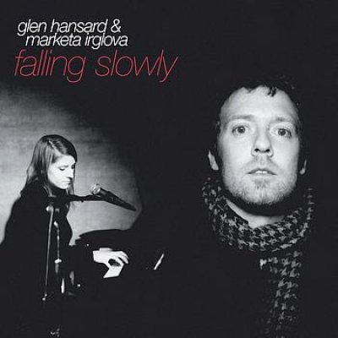Falling slowly

I don't know you  
But I ….….. you  
All the more for that  
Words fall through me  
And ……… fool me  
And I can't react  
And ………… that never amount  
To more than they're meant  
Will …….… themselves out

Take this sinking boat and point it ..……  
We've still got time  
Raise your hopeful voice, you ..……. a choice  
You'll make it now

Falling slowly, ……… that know me  
And I can't go back  
And moods that ……..… me and erase me  
And I'm painted black  
Well, you have suffered enough  
And warred with yourself  
It's …….. that you won